ST ALBAN’S CATHOLIC PRIMARY SCHOOL

Christ Be Our Light

ICT Code of Conduct for Pupils

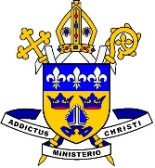

ICT Code of Conduct

We will respect the equipment and not attempt to alter any settings.

We will keep passwords secret.

We will only use IT equipment with permission and keep on the task set.

We will save work in the appropriate folders before closing a program.

We will not open anyone else’s personal folder without their permission.

We will ask permission to use USB data storage and ensure that this is checked by the ICT technician before use

We will always use polite language when using the computer.

We will only use the Internet if we have the permission of a teacher.

We will acknowledge other people’s work and not pretend it is our own.

We will ask permission before printing out our work.

We will not give out any personal information about others or ourselves on the Internet.

If we see or receive anything upsetting or that we are unsure about we will close the laptop lid, if it is iPad put screen down and tell the teacher immediately.

