View this email in your browser
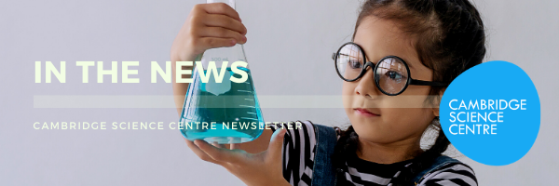
Win amazing prizes for you and your school with Cambridge Science Centre
Cambridge Science Centre are celebrating British Science Week this year with a competition for youngsters, with the chance to win prizes for themselves and their school.
We’d be grateful if you would share our competition with your teachers and parents - and perhaps, be amongst the winners!
Our communities are changing fast! Technology is moving at an ever-increasing pace. Interest in climate change, pollution, our local environment and beyond is increasing rapidly. School and home life is also changing as new technologies advance, and particularly so, as we navigate our way through the pandemic. But what will our future communities really look like? What do young people feel will make a huge difference to their lives, the way they learn, the way they work and how they will look after their families.
Cambridge Science Centre invites youngsters between 6-11 to think about how they would make a difference to their future community. They can choose any area of their community they wish to change. It could be the way they travel, how they recycle waste, how they attend school, the changes they would make to buildings they live or work in, places they visit, or even suggest changes to parks and playgrounds.
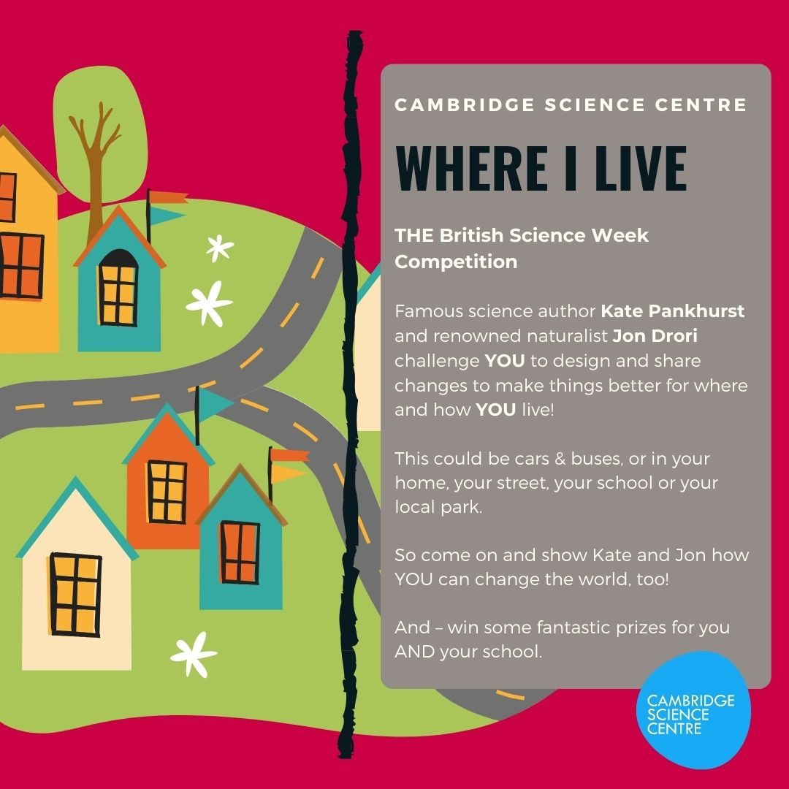
Their entries will be judged by famous science author Kate Pankhurst and renowned naturalist Jon Drori. Together, with Cambridge Science Centre, they challenge youngsters to design and share changes to make things better for where and how they live!
Who can enter:
Ages: 6-8 years at Primary school or home educated.
Ages: 9-11 years at Primary school or home educated.
Amazing prizes!
Both first prize winners will receive £50 in Amazon vouchers, plus a bundle of great books and a gift bag of Cambridge Science Centre goodies.
Their school will also win access to one of our VirtualSchoolTrip shows.
Runners up will receive £25 of Amazon vouchers, plus several great books and a gift bag of Cambridge Science Centre goodies.
Their school will also win access to one of our VirtualSchoolTrip shows.
Thanks goes to our book sponsors, Bloomsbury Publishing, who have kindly donated the books from their fantastic range.
How to enter:
Submit either a single drawing, film, or model of your design with a short description of how and why you feel it will change your community. Only one entry can be submitted per child.
You can download a worksheet for your drawing from our website, www.cambridgesciencecentre.org. or send in a free hand drawing.
Remember to write your name, age, the school you attend and a contact telephone number for a parent or carer on your entry form.
Send your entries to competitions@cambridgesciencecentre.org by 15th March 2021. If you make a model, then please send it to Cambridge Science Centre, 44 Clifton Road, Cambridge, CB1 7ED.
Kate and Jon will announce the winner on 26th March 2021.
ENTER TODAY!

Save the Date for these Virtual Festivals:
British Science Week - 5 - 14 March
Cambridge Festival - 26 March - 4 April
If colleagues would like to sign up for our newsletter, please ask them to subscribe via this link.
Sign up for our newsletter

For more information please contact schools@cambridgesciencecentre.org
Copyright (C) 2021 Cambridge Science Centre. All rights reserved.
You are receiving this email because you opted into our newsletter mailing list.
Cambridge Science Centre
44 Clifton Road
Cambridge, Cambridgeshire CB1 7ED
United Kingdom
Add us to your address book
Update Preferences | Unsubscribe

