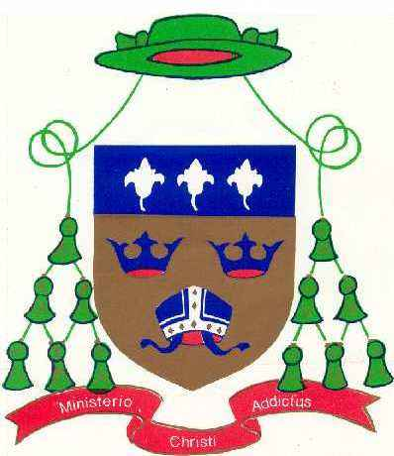
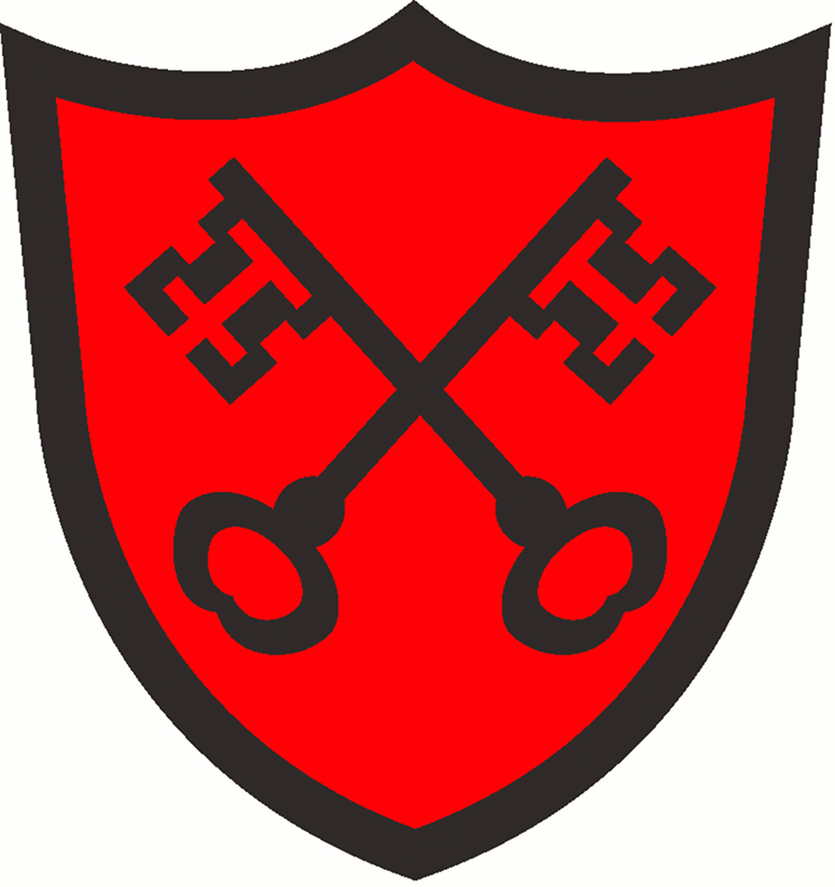
ST. ALBAN'S CATHOLIC PRIMARY SCHOOL
DIOCESE OF EAST ANGLIA
Christ Be Our Light

“St Alban’s School exists to ensure that all children believe, achieve and succeed”

Spelling Overview
Class: Year 2 Term: Autumn 2 2020

Objectives that are in blue are a Year 2 statutory requirement and individual words highlighted blue are from the Year 2 non-statutory example words and their exceptions. The additional words either reinforce the rule / pattern being taught; practice a spelling rule linked to a Year 2 statutory requirement or practice the common exception words.
Spelling checks will take place on Friday each week.
Week beginning  2nd November 2020  The sound /l/ spelt with ‘-le’ at the end of words. | Week beginning  9th November 2020  The sound /l/ spelt with ‘-el’ at the end of words. | Week beginning  16th November 2020  The sound /l/ spelt with ‘-il’ and ‘-al’ at the end of words.
table  apple  bottle  little  middle  able  wobble  multiple  dazzle  riddle | camel  tunnel  squirrel  travel  towel  tinsel  bagel  hazel  vowel  jewel | pencil  fossil  nostril  pupil  metal  pedal  capital  hospital  animal  oval
Week beginning  23rd November 2020  The sound /igh/ spelt with ‘-y’ at the end of words. | Week beginning  30th November 2020  Adding –ies to nouns and verbs ending in –y. | Week beginning  7th December 2020  Common Exception Words  *Please note, there will be no spelling test in the last week of term.
cry  fly  dry  try  reply  sly  shy  terrify  sky  multiply | flies  tries  replies  copies  babies  carries  cries  dries  marries  families | find  mind  behind  old  cold  gold  hold  told  every  everybody
Extension -
Can you put these words into sentences?

