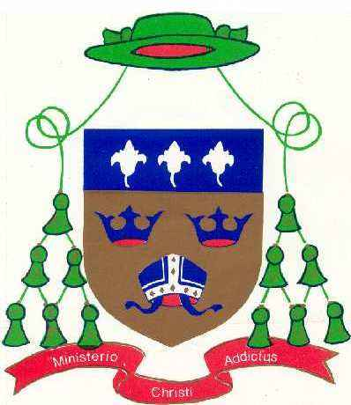
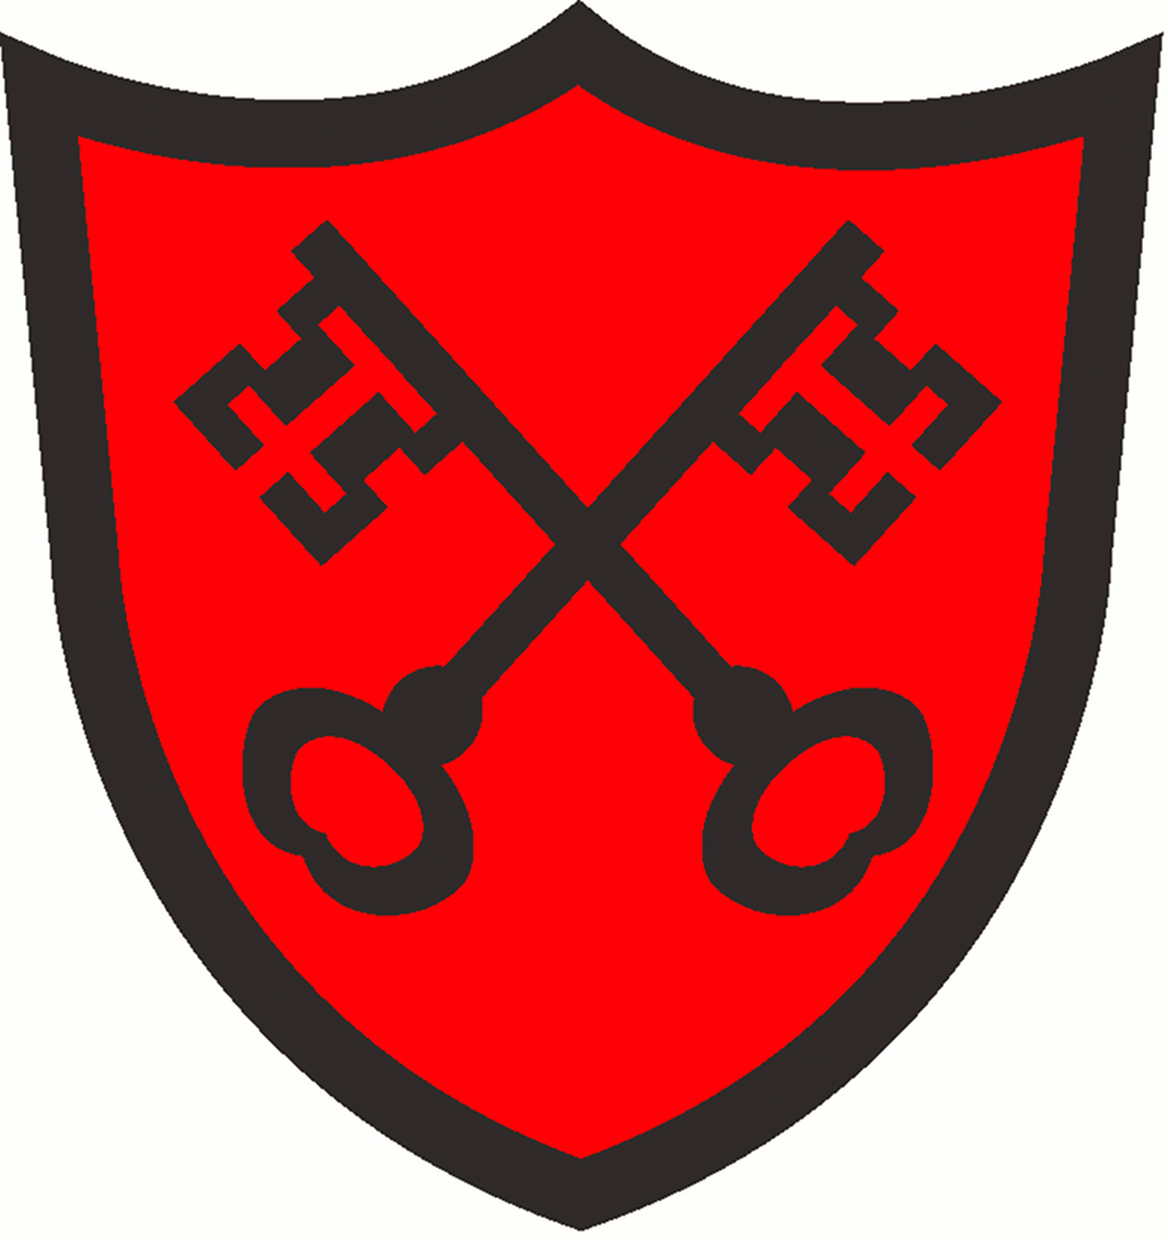
ST. ALBAN'S CATHOLIC PRIMARY SCHOOL
DIOCESE OF EAST ANGLIA
Christ Be Our Light

“St Alban’s School exists to ensure that all children believe, achieve and succeed”

Spelling Overview
Class: Year 2 Term: Autumn 1 2020

Objectives that are in blue are a Year 2 statutory requirement and individual words highlighted blue are from the Year 2 non-statutory example words and their exceptions. The additional words either reinforce the rule / pattern being taught; practice a spelling rule linked to a Year 2 statutory requirement or practice the common exception words.
Spelling checks will take place on Friday each week.
Week beginning  14th September 2020  The sounds /n/ spelt ‘kn’ and less often ‘gn’ at the beginning of words. | Week beginning  21st September 2020  The sound /r/ spelt ‘wr’ at the beginning of words. | Week beginning  28th September 2020  The sound /s/ spelt ‘c’ before e, i and y.
knock  know  knee  knitting  knife  gnat  gnaw  gnash  gnome  gnarled | write  written  wrote  wrong  wrap  wrist  wreck  wrestle  wriggle  wren | race  ice  cell  city  fancy  face  space  bicycle  circle  spicy
Week beginning  5th October 2020  The sound /j/ spelt with ‘-dge’ and ‘-ge’ at the end of words. | Week beginning  12th October 2020  The sound /j/ often spelt with g before e, i and y.  The sound /j/ always spelt with ‘j’ before a, o and u. | Week beginning  19th October 2020  Common Exception Words
badge  edge  bridge  dodge  fudge  age  huge  change  charge  village | gem  giant  magic  giraffe  energy  jacket  jar  jog  join  adjust | door  floor  again  wild  children  climb  parents  most  only  both
Extension -
Can you put these words into a sentence?

